Controlling the robot using your handphone [using your hotspot]

Change the ssid and password to your hotspot ssid and password

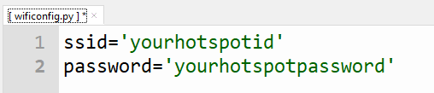

Turn your handphone hotspot on

Run robby.py – with the new wificonfig.py

Get the new ip address – it is now assigned by your hotspot

Start up a browser in your handphone

Enter the ip address

You should see the interface on your mobile phone and control the robot using it.

Please give it a go